**AIDI-2004: Artificial Intelligence in Enterprise Systems**

**Lab #1 – Git, GitHub, GitLab**

**Value:** 10%

**Introduction:**

You have learned about git, github and gitlab. In this lab, you will have hands-on experience by installing and using them in your machine.

**Instructions:**

Step 1: Marks: 10

Install git in your local machine

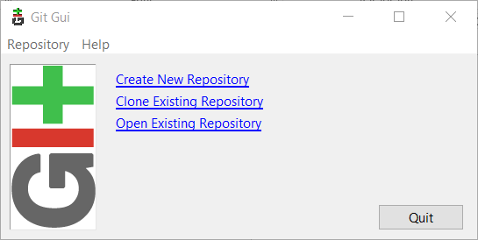

Step 2: Marks: 10

Create user accounts in both github and gitlab

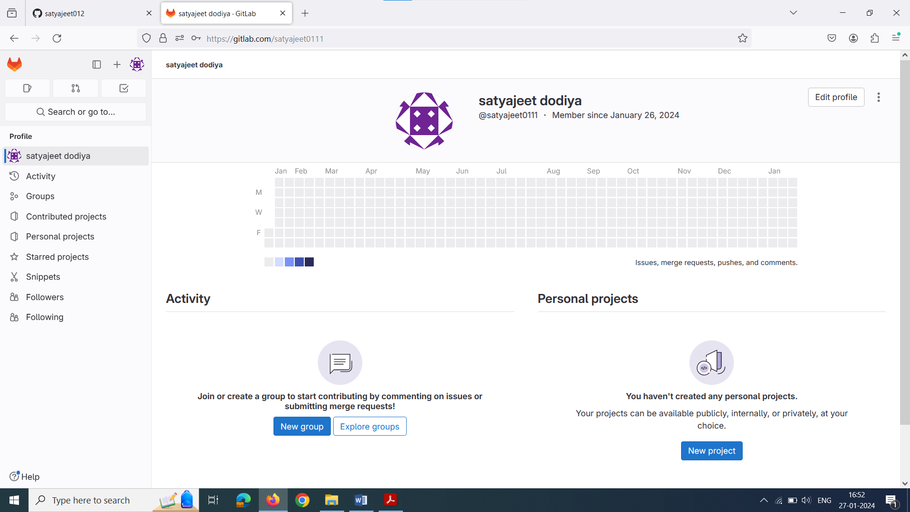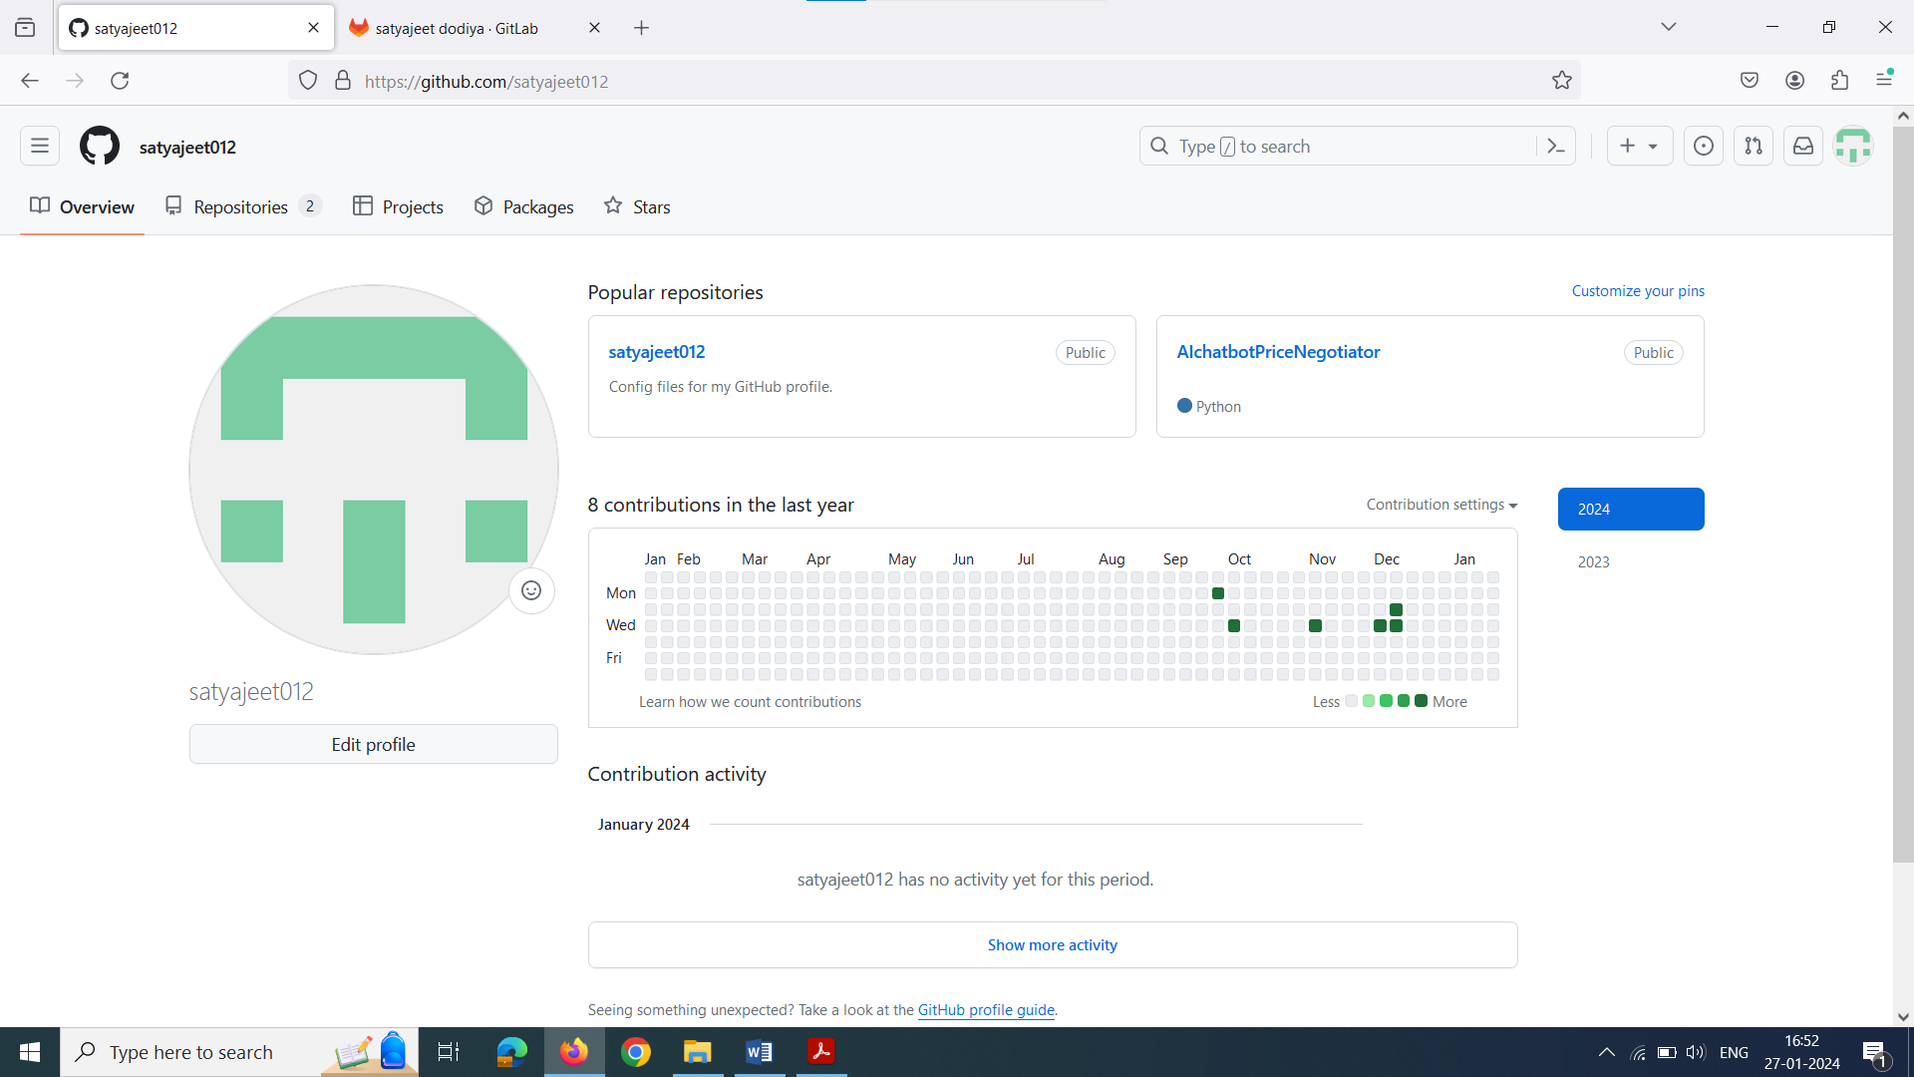

Step 3: Marks: 10

Review github and gitlab. Select your remote host (github or gitlab or any new one) and justify your selection.

After reviewing both,I Select GitHub because of its robust community support and broad appeal. Collaboration is a breeze with GitHub because to its massive repository hosting, user-friendly interface, and numerous integration options. Its strong ecosystem makes project administration easier, which makes it a great option for teams and developers searching for a dependable platform that is widely used.

Step 4: Marks: 10

Write a basic program performing key programming activities





Step 5: Marks: 10

Provide screenshot of your command prompt showing success of your commit in the remote host.

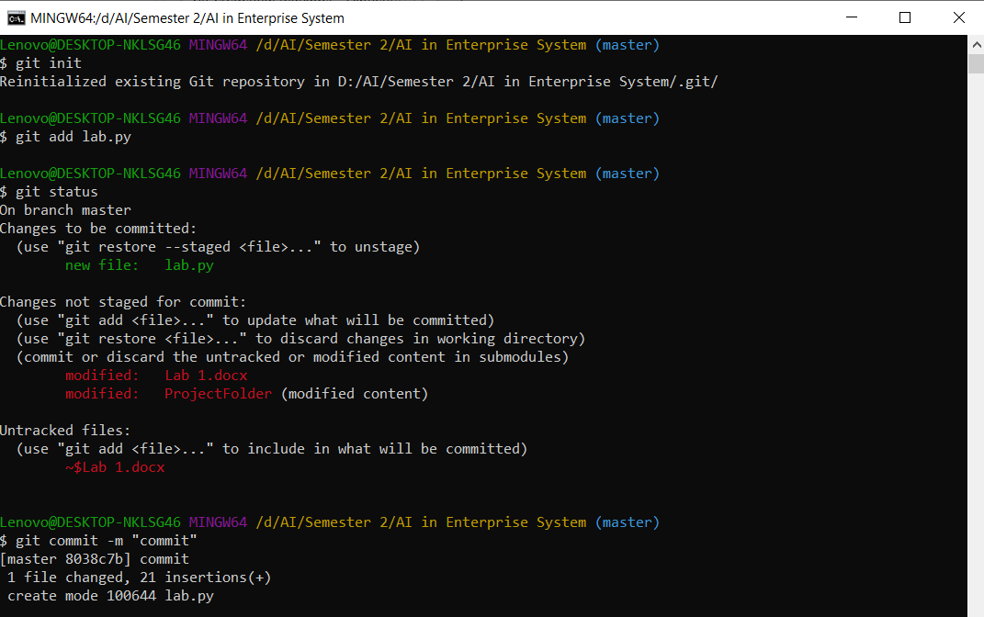

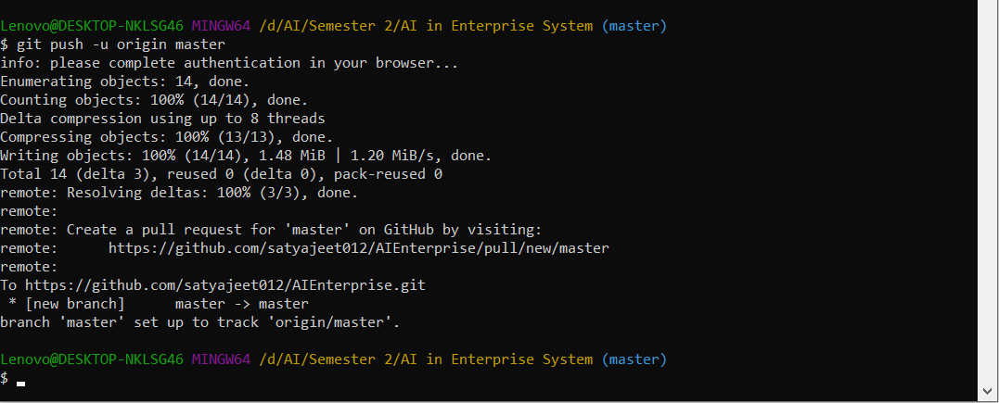

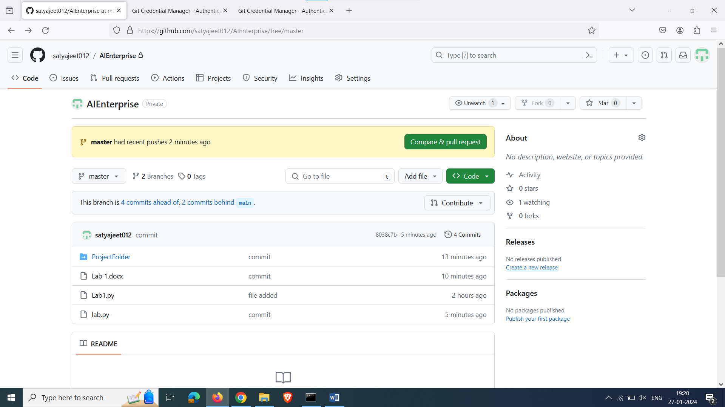

Step 6: Marks: 10

Provide a description of your program in the readme.md file

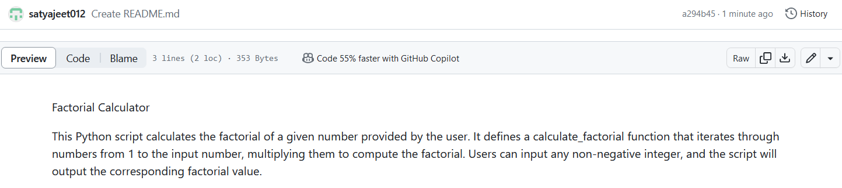

Step 7: Marks: 10

Create a branch in your repo and upload any python script in that branch

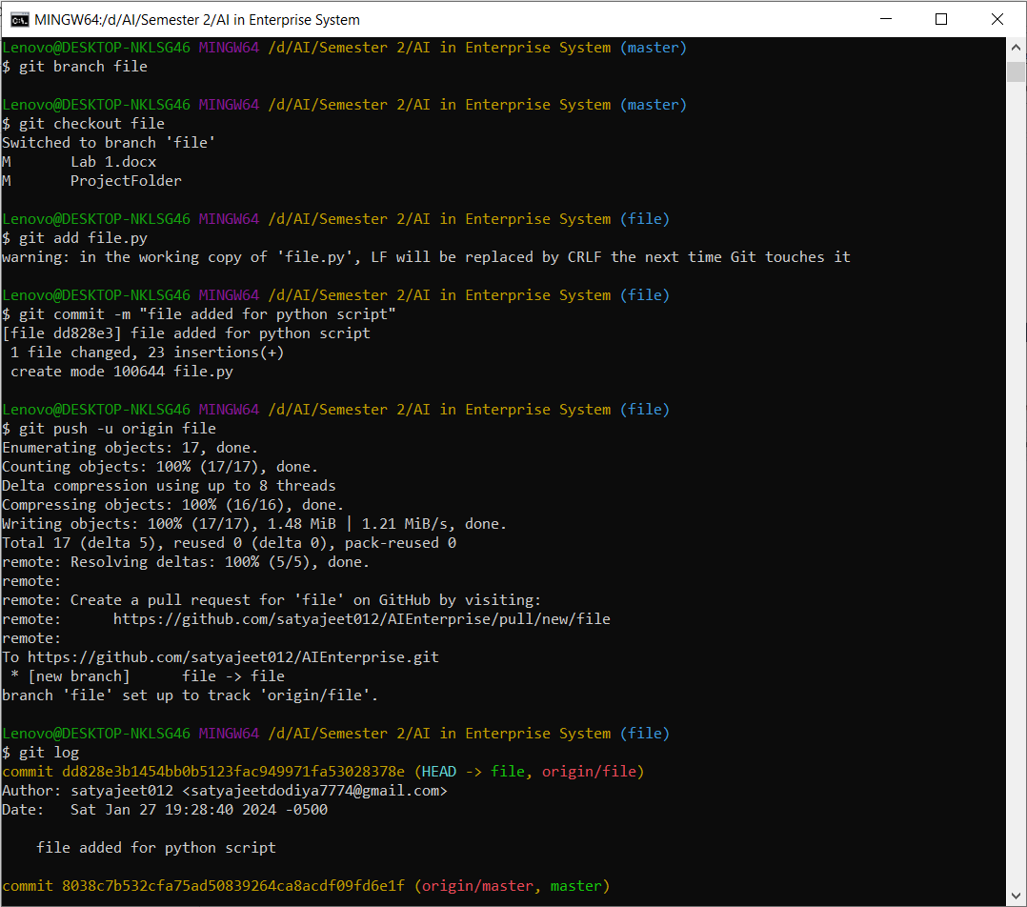

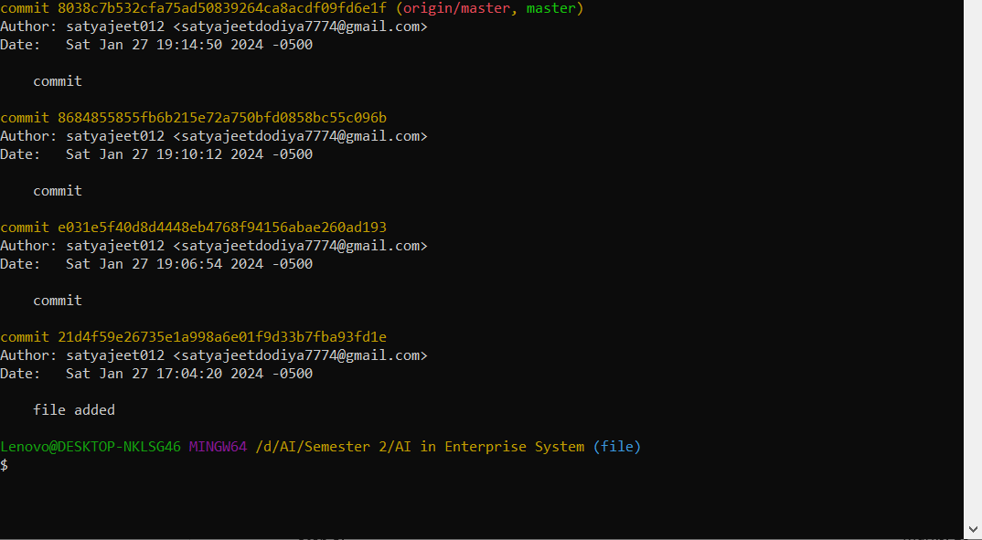

Step 8: Marks: 10

Navigate to your newly created branch and provide screenshot showing status of your repo

Step 9: Marks: 10

Provide a screenshot showing your log of activities and perform your final commit

Step 10: Marks: 10

Make your repo public and share the link of your repo for check.

**Submission:**

Submit a report identifying all the activities using DC connect

**This assignment relates to the following Course Learning Outcomes:**

CLO-2: Write industry standard code and use git to work in agile environment for developing enterprise AI products

CLO-6: Develop and deploy Enterprise AI solution pipeline using various technologies (i.e., Local,

Dockers, Heroku or cloud)

Lab #1 – Git